

Consultancy Report

ON

Preliminary Design of UNC Charlotte MARVEL Campus in Gastonia, North Carolina

Consultancy No. Group 1-01

November 20th - 2024

Sri Vishnu Consultancy Group 1

1

INDEX

SL | Contents | Page
 | Preface | 2
 | Synopsis | 3
1. | Introduction | 4
2. | Reference | 4
3. | SWOT Analysis | 4
4. | Recommendations | 4
5.
6. | Summary | 7
1-5 | Annexures | 10-14
 | Recommended Profile

PREFACE

This report is prepared on the basis of report submission & detailed discussion with the UNC Charlotte Design Team # 1 with Team CEO Addala varshini, Charlotte, NC, USA. Views expressed are subject to modification from time to time in the light of future developments on the subject and as such, do not represent the views of Sri Vishnu Engineering College for Women, Bhimavaram, Andhra Pradesh, India.

This report is the property of the SVECW and is meant essentially for officials use. It may not be loaned, reproduced in part or in full or quoted as an authority without the permission of Director General, RDSO.

(Brandon jones)
CEO/ Team Leader

(Addala varshini)

Communication Officer/Liaison to US Team

SYNOPSIS

UNC Charlotte MARVEL Campus Consultancy Report

Executive Summary

This report, prepared by Sri Vishnu Consultancy Group, presents the preliminary design for the UNC Charlotte MARVEL Campus in Gastonia, North Carolina. The report provides a comprehensive analysis of the site conditions, including soil analysis, material testing, and design recommendations.

Project Purpose

The objective of this consulting project is to provide a thorough analysis of the site conditions and develop a preliminary design for the UNC Charlotte MARVEL Campus, ensuring efficient and sustainable campus development.

Key Findings

The analysis revealed the following key findings:

- Detailed test results for embankment and sub-soil conditions, including moisture content, density, and shear strength.
- A comprehensive SWOT analysis, highlighting the project's strengths, weaknesses, opportunities, and threats.

Recommendations

Based on the analysis, the following strategic recommendations are proposed:

- Implementation of sustainable design principles to minimize environmental impact.
- Optimization of campus layout to ensure efficient use of space.
- Development of a comprehensive infrastructure plan to support campus growth.

Conclusion

This report provides a comprehensive analysis of the site conditions and presents a preliminary design for the UNC Charlotte MARVEL Campus. The recommendations outlined in this report aim to guide efficient and sustainable campus development, ensuring a successful project outcome.

- Introduction

Conceptual Designs for the MARVEL Campus

Introduction

The MARVEL Campus is a cutting-edge satellite campus for UNC Charlotte, designed to advance sustainable transportation research and education. This report presents three conceptual designs for the campus, each featuring innovative and functional layouts.

Design Overview

Each design features three primary research and academic buildings:

- Engineering Education Building: A state-of-the-art facility for teaching and learning, equipped with cutting-edge laboratories and collaborative workspaces.
- Flexible Research Laboratory: A highly adaptable and customizable research space, designed to accommodate a wide range of research projects and collaborations.
- Rail Sparc: A unique research and testing facility focused on rail transportation and logistics, featuring advanced simulation and testing capabilities.

Design 1: Adaptive Reuse

This design preserves existing structures on the campus, incorporating a RailSparc hub, playground, and communal spaces to foster collaboration and community engagement. Key features include:

- Adaptive reuse of existing buildings to minimize waste and environmental impact.
- Integration of green spaces and communal areas to promote social interaction and well-being
- Rail Sparc hub and research facilities to support cutting-edge rail transportation research

Design 2: Efficient Infrastructure

This design minimizes rail infrastructure, centralizing the water pond and parking to prioritize efficiency and reduce environmental impact. Key features include:

- Optimized campus layout to reduce walking distances and promote a more efficient use of space
- Centralized water pond and parking facilities to minimize environmental impact and reduce maintenance costs
- Emphasis on sustainable design principles and energy-efficient systems

Design 3: Reconfigured Campus

This design reconfigures the campus, removing select buildings to improve functionality and aesthetics, while enhancing the overall user experience. Key features include:

- Reconfigured campus layout to improve navigation and wayfinding
- Removal of select buildings to reduce maintenance costs and environmental impact
- Enhanced green spaces and communal areas to promote social interaction and well-being

Innovative Features

All designs incorporate innovative additions, including:

- Drone testing areas: Designated spaces for testing and developing unmanned aerial vehicles (UAVs)
- Water research pond: A controlled environment for researching and testing water-based systems and technologies
- "Sustainable Trees of Life": Innovative, tree-like structures that integrate solar panels, wind turbines, and green roofs to provide sustainable energy and reduce carbon emissions

2.0 Reference

Academic and Research Institutions

- UNC Charlotte: As the parent institution of the MARVEL Campus, UNC Charlotte's website and publications can provide valuable information on research initiatives, academic programs, and campus development.
- National Science Foundation (NSF): As a potential funding agency for research initiatives at the MARVEL Campus, the NSF website can offer insights into research priorities, funding opportunities, and best practices in STEM education and research.
- Transportation Research Board (TRB): As a division of the National Academies of Sciences, Engineering, and Medicine, TRB provides leadership and guidance on transportation research and policy.

Industry and Government Partners

- Charlotte Area Transit System (CATS): As a potential partner for transportation-related research and initiatives, the CATS website can provide information on current projects, partnerships, and transit planning efforts.
- North Carolina Department of Transportation (NCDOT): As a state agency responsible for transportation infrastructure, the NCDOT website can offer insights into transportation planning, policy, and project development.
- Federal Highway Administration (FHWA): As a division of the US Department of Transportation, FHWA provides guidance and funding for highway and transportation infrastructure projects.

Sustainability and Transportation Resources

- United States Department of Transportation (USDOT): The USDOT website provides information on transportation policy, research initiatives, and funding opportunities, with a focus on sustainability and environmental stewardship.
- Environmental Protection Agency (EPA): The EPA website offers resources on sustainability, environmental policy, and green infrastructure, including guidance on environmentally friendly transportation systems.
- American Planning Association (APA): The APA website provides resources and guidance on urban planning, transportation planning, and sustainability, with a focus on creating livable and sustainable communities.

News and Media Outlets

- Charlotte Business Journal: A local business publication that covers news and developments related to the MARVEL Campus and UNC Charlotte, including stories on research initiatives, industry partnerships, and campus growth.
- The Charlotte Observer: A local newspaper that covers news and developments related to the MARVEL Campus and UNC Charlotte, including stories on research initiatives, campus life, and community engagement.
- Transportation Today: A national transportation publication that covers news and developments related to transportation policy, research initiatives, and industry trends.

Research and Academic Journals

- Transportation Research Record: A peer-reviewed journal that publishes research on transportation policy, planning, and operations.
- Journal of Transportation Engineering: A peer-reviewed journal that publishes research on transportation engineering, including topics such as transportation infrastructure, traffic management, and transportation planning.
- Sustainability: A peer-reviewed journal that publishes research on sustainability, including topics such as sustainable transportation, green infrastructure, and environmental policy.

3.0 SWOT Analysis

STRENGTHS ANALYSIS

 | No | Strengths Item
 |  |  | Design 1 | Design 2 | Design 3
 | 1 | Community Support (Do you think community will like this design) | 3 | 4 | 3
 | 2 | Infrastructure Availability (layout) | 4 | 7 | 9
 | 3 | Sustainable design | 2 | 5 | 7
 | 4 | Design efficiency (Site Use) | 4 | 6 | 8
 | 5 | Design Readiness | 7 | 6 | 3
 | 6 | Stormwater | 4 | 6 | 9
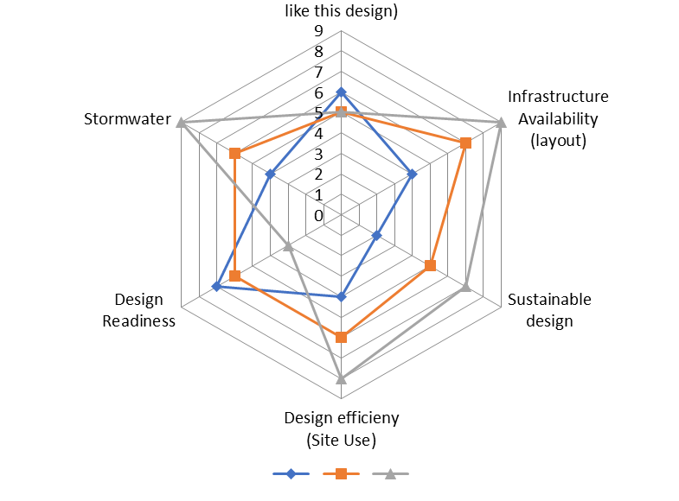
WEAKNESSES ANALYSIS

No | Weaknesses Item
 |  | Design 1 | Design 2 | Design 3
1 | Financial Support (cost) | 9 | 4 | 3
2 | Infrastructure Modification (result in many site changes) | 7 | 4 | 2
3 | Earthwork (require more earthwork) | 5 | 8 | 3
4 | Post Services (maintenance) | 9 | 5 | 4
5 | access problem | 6 | 9 | 4

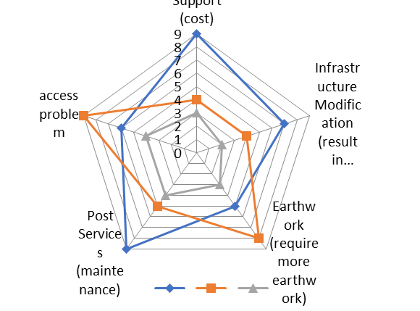
OPPORTUNITIES ANALYSIS

 | No | Opportunities Item
 |  |  | Design 1 | Design 2 | Design 3
 | 1 | Environmental Sustainability | 7 | 3 | 3
 | 2 | Good Profit (help to local community) | 5 | 6 | 7
 | 3 | Economic growth | 2 | 8 | 9
 | 4 | Urban innovation | 5 | 5 | 6
 | 5 | Exclusive contracts | 5 | 7 | 8
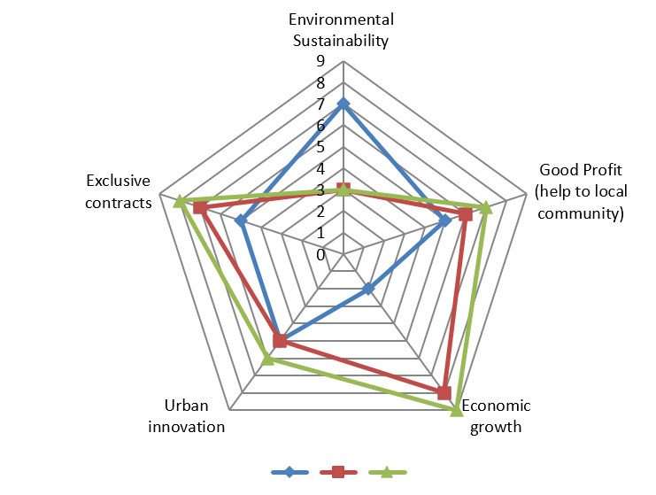


THREATS ANALYSIS

No | Threats Item
 |  | Design 1 | Design 2 | Design 3
1 | Political Effect (local community will not like the design) | 8 | 6 | 5
2 | Alternate Design (may face competition) | 6 | 4 | 2
3 | Market Demand | 8 | 7 | 3
4 | Economic Situation (too expensive to build) | 4 | 6 | 7
5 | local ecology | 5 | 7 | 8

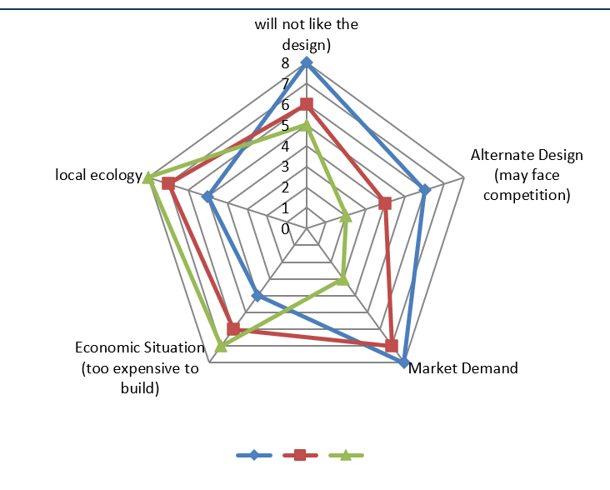

4.0 Recommendations

Strengths

The MARVEL Campus boasts several strengths that position it for success. Its state-of-the-art research facilities provide students and faculty with hands-on experience in transportation and logistics research. Additionally, the campus's industry partnerships offer valuable resources, expertise, and job opportunities for students. The campus's interdisciplinary approach to research and education also fosters a unique and innovative approach to solving complex transportation and logistics challenges.

Weaknesses

Despite its strengths, the MARVEL Campus also faces several weaknesses. One of its primary challenges is limited resources, including funding, personnel, and equipment. The campus's dependence on industry partnerships also creates uncertainty and vulnerability in the event of changes in the industry or economy. Furthermore, the campus faces competition from established institutions with more resources, reputation, and networks. Finally, the campus may struggle to attract and retain top talent, including students, faculty, and staff.

Opportunities

The MARVEL Campus has several opportunities to capitalize on the growing demand for transportation and logistics professionals. The campus can leverage emerging technologies, such as autonomous vehicles and drones, to establish itself as a leader in transportation and logistics research and education. Partnerships with government agencies can also provide opportunities for the campus to contribute to policy development and implementation. Additionally, the campus can explore international collaborations to engage in global research and education initiatives.

Threats

The MARVEL Campus faces several threats that could impact its success. Changes in government policies and funding priorities can impact the campus's ability to secure funding and support for its research and education initiatives. The campus also faces competition from new and emerging institutions and programs in transportation and logistics. Economic downturns can also impact the campus's ability to secure funding, attract students, and maintain partnerships with industry and government agencies. Finally, the campus must be mindful of reputation and branding challenges, particularly in the early stages of its development.
5.0 Summary Of Test Results

Test results of samples from Ch.7700 to Ch.9200 are tabulated below:

 |  | Embankment Soil (Fill material) |  |  |  |  |  |  | Sub-Soil (Alignment soil)
Tests Name |  |  | Ch.7990 |  | Ch.8350 | Ch.8450 | Ch.8650 | Ch.8000 | Ch.8250 |  | Ch.8600 | Ch.8700 | Ch.8900
Soil Sample D*/UD* |  |  | D |  | D | D | D | UD | UD |  | UD | D | UD
Soil Classification |  |  | GM |  | SM | SW-SM | SM | SM | SM |  | SW-SM | SM | SM
Natural Moisture |  | Content | - |  | - | - | - | 29.88 | 20.56 |  | 15.89 | - | 19.16
(NMC)%
Natural Dry density gm/cc |  |  | - |  | - | - | - | 1.331 | 1.631 |  | 1.056 | - | 1.349
Gravel (%) |  |  | 54 |  | 08 | 08 | 22 | 03 | 12 |  | 23 | 20 | 16
Sand (%) |  |  | 31 |  | 70 | 83 | 64 | 48 | 55 |  | 66 | 58 | 36
Silt (%) |  |  | 14 |  | 22 | 09 | 14 | 48 | 30 |  | 11 | 22 | 44
Clay (%) |  |  | 00 |  | 00 | 00 | 00 | 01 | 03 |  | 00 | 00 | 04
Passing 75 | micron sieve |  | 14 |  | 22 | 09 | 14 | 49 | 33 |  | 11 | 22 | 48
(%)
Optimum Moisture content |  |  | 12.80 |  | 9.20 | 9.60 | 10.00 | - | - |  | - | 11.00 | -
(%)
Maximum | Dry | Density | 1.893 |  | 1.720 | 1.890 | 1.884 | - | - |  | - | 1.872 | -
gm/cc
Specific Gravity |  |  | 2.49 |  | 2.25 | 2.36 | 2.04 | 2.54 | 2.43 |  | 2.43 | 2.30 | 2.34
Consistency Limits
Liquid Limit (LL) % |  |  | NP |  | NP | NP | NP | 46 | 40 |  | 49 | NP | 60
Plastic Limit (PL) % |  |  | NP |  | NP | NP | NP | 28 | 27 |  | 33 | NP | 34
Plasticity Index |  |  | NP |  | NP | NP | NP | 18 | 13 |  | 16 | NP | 26
Shear Parameters (CU) test Triaxial
Cohesion (Cʹ) kg/cm² |  |  | 0.01 |  | 0.006 | 0.000 | 0.006 | 0.044 | 0.034 |  | 0.022 | 0.007 | 0.050
Angle of Internal |  | Friction | 35.04 |  | 33.22 | 34.25 | 33.77 | 30.32 | 31.39 |  | 35.09 | 33.01 | 31.94
(ϕʹ) degree

*D : Disturbed Soil Sample

*UD : Un-Disturbed Soil Sample

6.0 Summary

Officers And Staff Associated with Preparation Of report

The report has been prepared by Addala varshini, CEO/Team Leader under guidance of Dr. Pala, HOA.

This report has been prepared on the basis of _.

The following officer and staff that were associated with the preparation of report.

- , UG student
- , US student
- ,

Annexure – 1

